Exercise3.

Make an Online Airline Reservation System. The activities of the Online Airline

Reservation system are listed below user, admin, LOGIN, MANANGE CLASSES,

MANANGE WAITING LIST, MANAGE HOLDS, MANAGE DEADLINES,

LOGOUT, using this has a step-by-step process draw a CLASS diagram.

Aim:

The aim is to create a Class Diagram for an Online Airline Reservation System that models the structure and relationships between key components such as User, Admin, Flight, Reservation, Class, Waiting List, Hold, and Deadline. The system allows users to book flights, manage reservations, and perform administrative tasks like managing classes, waiting lists, holds, and deadlines.

Procedure:

Identify Key Classes:

User: Represents a customer who books flights.

Admin: Manages system operations like managing classes, waiting lists, holds, and deadlines.

Flight: Represents a flight with details like flight number, departure, arrival, and seats.

Reservation: Represents a booking made by a user.

Class: Represents the class of travel (e.g., Economy, Business).

Waiting List: Manages passengers waiting for available seats.

Hold: Represents a temporary hold on a seat.

Deadline: Represents deadlines for reservations or payments.

Define Attributes and Methods:

User: Attributes (userID, name, contact), Methods (login, bookFlight, logout).

Admin: Attributes (adminID, name), Methods (manageClasses, manageWaitingList, manageHolds, manageDeadlines, logout).

Flight: Attributes (flightID, departure, arrival, totalSeats, availableSeats), Methods (checkAvailability).

Reservation: Attributes (reservationID, user, flight, class, status), Methods (confirmReservation, cancelReservation).

Class: Attributes (classID, className, price), Methods (updatePrice).

Waiting List: Attributes (waitingListID, flight, user), Methods (addToWaitingList, removeFromWaitingList).

Hold: Attributes (holdID, flight, user, expirationTime), Methods (placeHold, releaseHold).

Deadline: Attributes (deadlineID, flight, deadlineTime), Methods (setDeadline, checkDeadline).

Define Relationships:

A User can make multiple Reservations.

A Reservation is associated with a Flight and a Class.

A Flight can have multiple Classes.

A Flight can have a Waiting List and Holds.

An Admin manages Classes, Waiting Lists, Holds, and Deadlines.

Output:

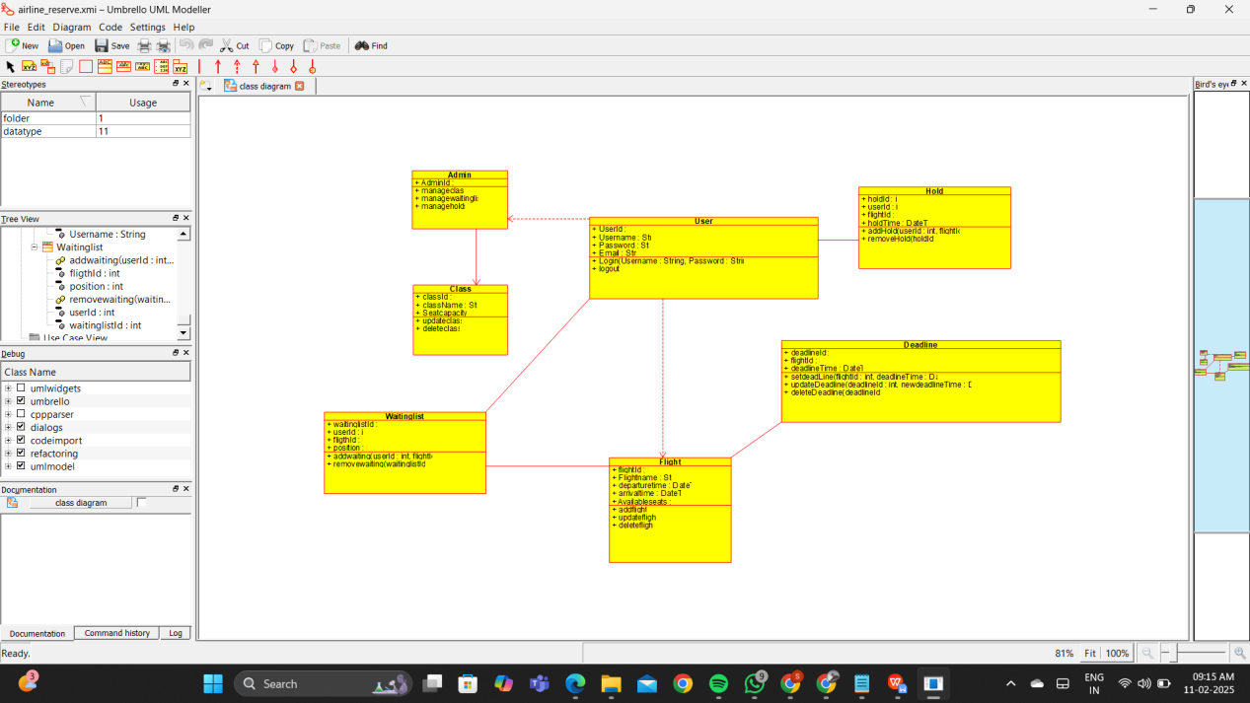

Result :

Thus the UML diagram has been implemented successfully.